44-560 Advanced Topics in Database Systems

ER Modeling Review Exercises KEY
Do not use surrogate keys unless the problem specifically asks you to do so.
- Draw an ER diagram to represent each of the following. No attributes are included. Your diagram will include only the entities and the relationship between the entities:
  - A team has exactly one person assigned as team leader. A person is assigned as team leader to at most one team.
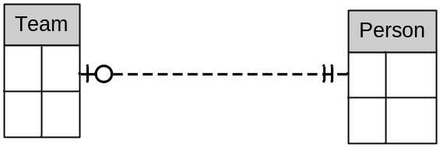
  - A course has exactly one instructor. Instructors teach one or more courses.
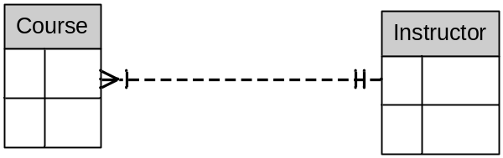
- Draw an ER diagram to represent the entity STUDENT with the following attributes: student id (a unique identifier), name (first and last), address (street, city, state, zip), and gpa.
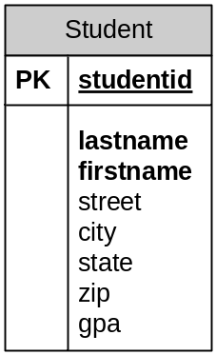
- Draw an ER diagram to represent the entity STUDENT with the attributes described above and the additional attributes phone number, major, total credit hours earned, and classification. A student may have several majors and also may have several phone numbers.
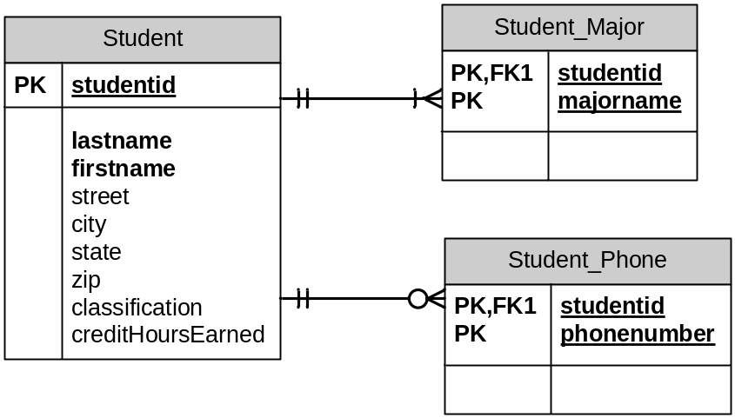
Your cardinalities on the “many” side may differ from those shown above. Both relationships must be mandatory one into Student, since both Student_Major and Student_Phone are weak with respect to Student. Cardinalities into Student_Major and Student_Phone must be “many,” but there is insufficient information to determine whether the cardinalities should be mandatory or optional, so it is your choice. In the model shown above, we are assuming that some students may not have any phone, so have used optional many as the cardinality into Student_Phone. For Student_Major we are assuming that there is a major id corresponding to unknown or undecided majors, and so are using mandatory one as the cardinality into Student_Major. You may have made different assumptions, and that is ok, just so you have “many” as the cardinality into Student_Major and Student_Phone.

- Draw an ER diagram to represent the following scenario. We wish to store information about students and the courses they have taken. For students, we will store the student id and the name of the student. For courses, we will store the course id and the title of the course.
Every student has taken at least one course. A course is taken by many students, but some new courses may not have been taken by any student. For each course taken by a student, we also store the grade.
Assume a student can never repeat a course, even to supersede, or even if the content is different.
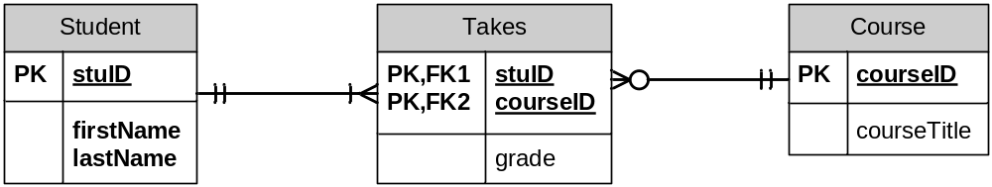
- Repeat the previous problem, but assume a student may repeat a course. However, a student cannot take the same course twice in a single semester. That is, if a student repeats the course, it must be during a different semester. (A semester is designated by the term – fall, spring, or summer – and the year.)
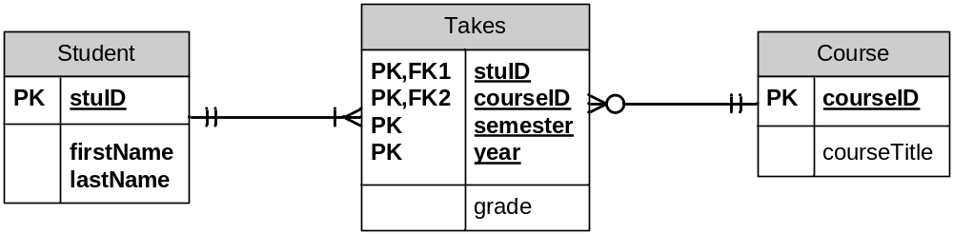
- Draw an ER diagram to represent the following scenario. We wish to store information about faculty members and students. For each faculty member we will store his/her unique identification number, name (first and last), and rank (Assistant Professor or Full Professor, for example). For each student we will store the 919 number, name (first and last), and overall gpa.
Faculty members teach students. Occasionally a faculty member will be on leave and will teach no students but most faculty members teach many students. Between terms a student may not have any teachers, but most students have several teachers.
In addition, faculty members advise students. Every student has exactly one advisor. Most faculty members advise many students, but some have no advisees.
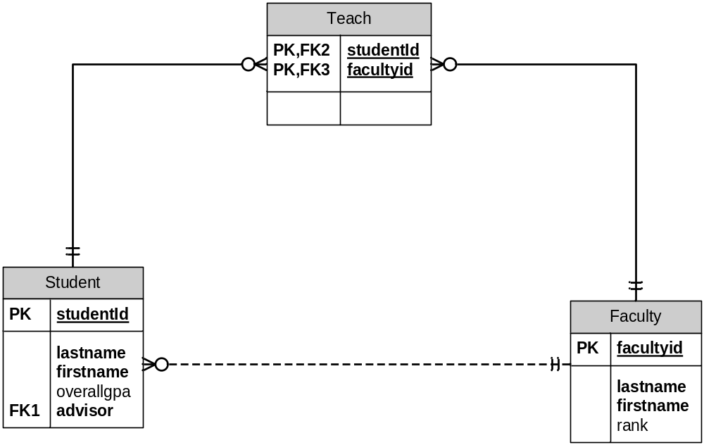
- Draw an ER diagram to represent the following scenario. Vendors supply parts to warehouses. A vendor may supply many parts to many warehouses, but some vendors supply no parts to any warehouses. Each part is supplied by at least one vendor to at least one warehouse. Each warehouse is supplied by many different vendors with many different parts. Some newly constructed warehouses initially have no parts supplied by any vendor.
For each vendor we store a unique vendor id and the vendor name. For each part, we store the part number (a unique identifier) and the description of the part. For each warehouse we store a unique warehouse number and the location (city and state) of the warehouse. We also store the cost of each part supplied by each vendor to each warehouse. The price that a vendor charges for a part is dependent on the warehouse to which the part is being shipped.
Hint: This is a ternary relationship. A single relationship exists between the three entities Vendor, Part, and Warehouse.
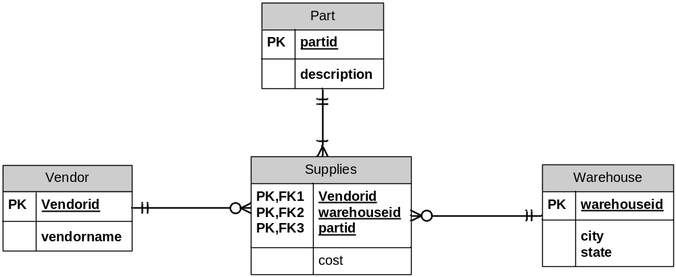
- Draw an ER diagram for the following scenario: We want to keep the following information about residents in an assisted living facility: resident identifier, first and last name, level of care (low, moderate, or high), and room type (efficiency, one-bedroom, two-bedroom).
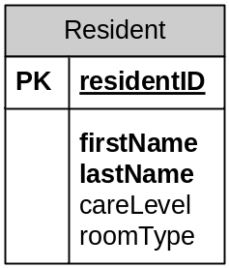

- Draw an ER diagram for the following scenario: As part of the database for the physical plant for a hospital we store information about each of the buildings, the wings within each building, and the rooms within each wing. For each building, we store the building’s unique identifier and the building name. For each wing, we store the wing number, and a description of the purpose of the wing (pediatric, surgery, cardiac, etc.). Within a building, the wing number uniquely identifies a wing. For each room, we store the room number, and the type of room (private, double, special-care, etc.). Within a wing, the room number uniquely identifies a room.
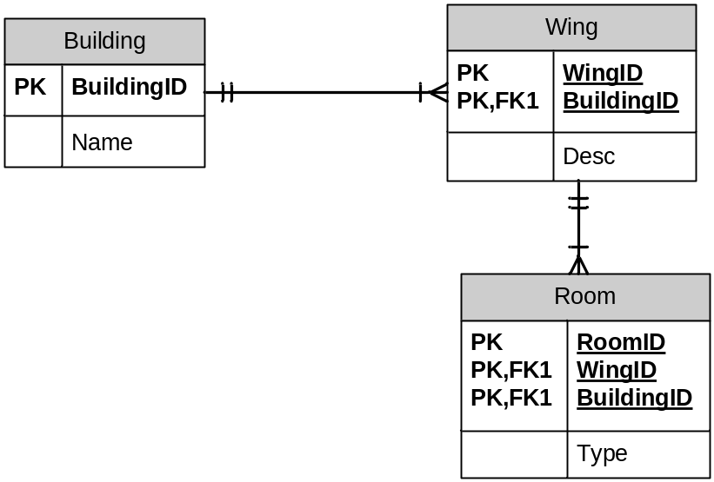
Note: Cardinalities on the “many” side may be either optional many or mandatory many. There is insufficient detail in the description to make this determination. The relationships on the “one” side must be mandatory one in both instances.

- Draw an ER diagram for the assisted care facility described here.
The Just Like Home assisted care facility maintains information about residents, guardians (of the residents), physicians, and rooms. Resident information includes the resident id number (identifier), name (first and last), the care plan chosen (minimal, moderate, high), the most recent date of entry into the facility, and the number of years at the facility (since the most recent entry date).
Information maintained for guardians includes a guardian id number, guardian name (first and last), and phone numbers. A guardian has at least one phone number and may have several phone numbers (home, business, fax, cellular, etc.). A person designated as a guardian is the guardian of at least one resident and may be the guardian of more than one resident. Each resident is assigned exactly one guardian. The relation of the guardian to the resident (son, daughter, niece, …) is also stored.
Each resident is assigned exactly one primary care physician. Information maintained for physicians includes physician id number (identifier), name (first and last), and office phone number. A physician may have many residents assigned to him/her, but some physicians have no residents assigned.
Each resident is assigned to exactly one room. Information maintained for rooms includes the room number (identifier), the number of beds in the room, whether it is equipped with kitchen facilities, and area (in square feet). Some rooms have no residents in them, and some rooms are shared by two residents.
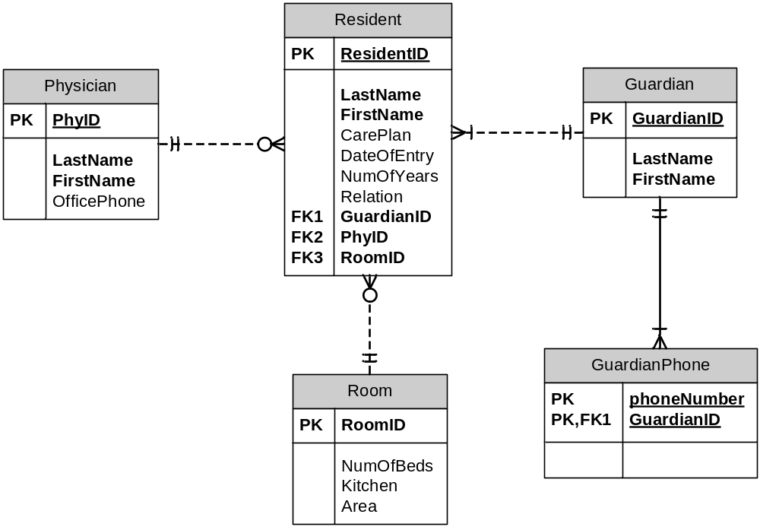
Note that NumOfYears in Resident is a derived entity – it can be calculated from other data in the database by performing date arithmetic on today’s date (from the computer system) and the attribute DateOfEntry. The attribute NumOfYears might be omitted from the actual database, since it can be calculated whenever necessary.
Also note that the attribute Relation is stored with Resident, not with Guardian. A guardian can be designated as the guardian of more than one resident, and the guardian may be a different relation to different residents. For example, a guardian might be the daughter of one of the residents and the niece of another. The attribute relation depends on the resident, not the guardian – each resident has exactly one guardian, and that guardian has a specific relation to the resident (son, daughter, niece, etc.). Therefore the attribute Relation must be stored in the Resident table.
- Draw an ER diagram for the following scenario. This scenario is adapted from a case study in Modern Database Management (Seventh Edition) by Jeffrey A. Hoffer, Mary B. Prescott, and Fred R. McFadden. Published by Prentice-Hall. ISBN: 0-13-145320-3.
Assume you are part of a team to develop a high-level E-R diagram for Mountain View Community Hospital. Your team has conducted interviews with the hospital staff and has identified the following entities described below.

- Care center -- a treatment center within the hospital. Examples of care centers are maternity and emergency care. Each care center has a care center number (identifier) and a care center name.
- Patient -- a person who is admitted to the hospital. Each patient has a patient number (identifier) and name.
- Physician -- a member of the medical staff who may refer patients to the hospital and who may administer medical treatments. Each physician has a physician ID (identifier) and name.
- Room -- a room that contains beds for patients. Each room is located in one care center. Data stored for a room includes the room number (identifier within a care center) and the number of beds in the room.
- Bed -- a hospital bed that may be assigned to a patient. Each bed is located in one room. Within a room, the bed number identifies a specific bed. The type of bed must also be stored.
- Item -- any billable item. Each item has an item number (identifier), description, and unit cost. In addition, an item type is stored for each item. Examples of item type include Medical/Surgical (IV equipment, catheters, etc.) and Personal (room TV, special bedding, etc.).
- Employee -- any person employed as part of the hospital staff. Each employee has an employee number (identifier) and name.
- Treatment -- any test or procedure performed by a physician on behalf of a patient . Each treatment has a treatment number (identifier) and a description.

The team has also recorded the following information concerning relationships.

- Each hospital employee is assigned to work in one or more care centers. Each care center has at least one employee, and may have any number of employees. The hospital records the number of hours per week that a given employee works in a particular care center.
- Each care center has exactly one employee who is designated nurse in charge for that care center. An employee may be in charge of at most one care center.
- Each patient is assigned to exactly one bed. A bed may or may not be assigned to a patient.
- A patient must be referred to the hospital by exactly one physician. A physician may refer any number of patients, or may not refer any patients.
- Physicians may perform any number of treatments on behalf of any number of patients, or may not perform any treatments. A patient may have treatments performed by any number of physicians, or may have no treatments performed. A treatment may be performed by any number of physicians on behalf of any number of patients. Some treatments may not be performed on any patients. A physician may perform the same treatment on the same patient more than once, but never more than once per day.
- For each treatment performed on behalf of a given patient by a particular physician, the hospital records the following information: treatment date, treatment time, and results.
- A patient may optionally consume any number of items. A given item may be consumed by one or more patients, or may not be consumed by any patients. For each item consumed by a patient, the hospital records the following information: date, quantity, and total cost (which can be computed by multiplying quantity times unit cost).
- Every care center has at least one room.
- Every room contains at least one bed.

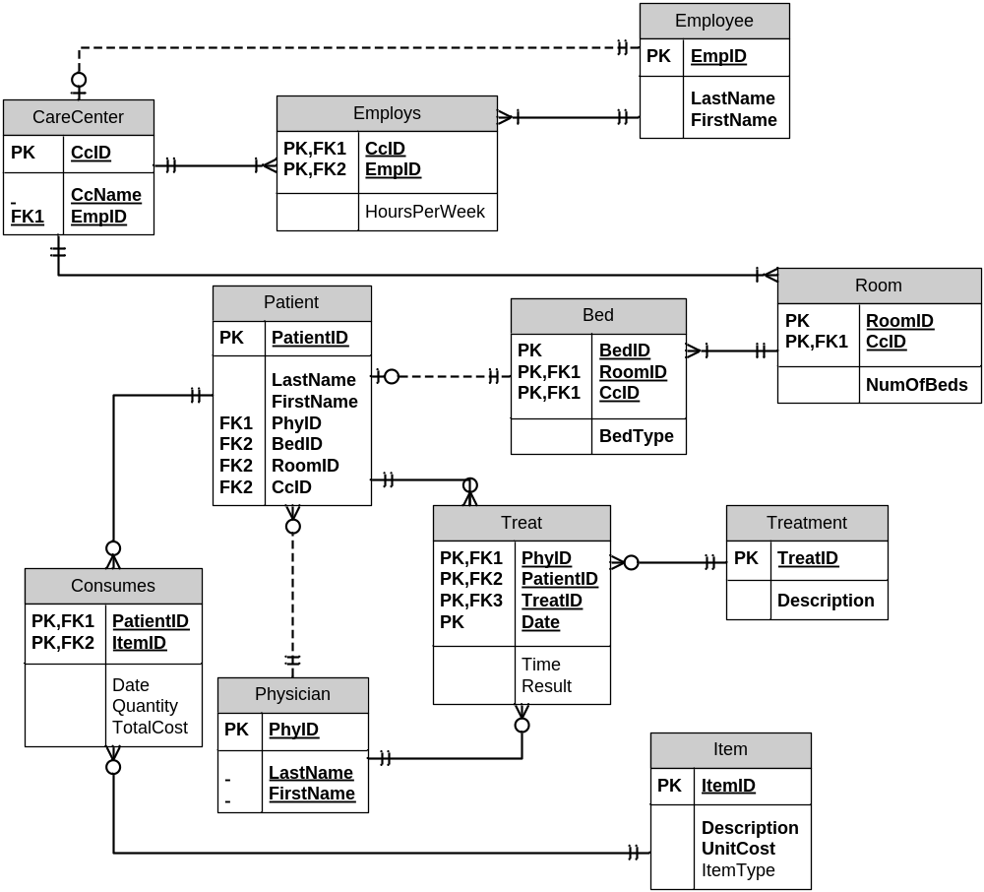

Note that TotalCost in Consumes is a derived entity – it can be calculated from other data in the database by multiplying Quantity and UnitCost. The attribute TotalCost might be omitted from the actual database, since it can be calculated whenever necessary.

